

Pranshu Mishra

*MCA Student*

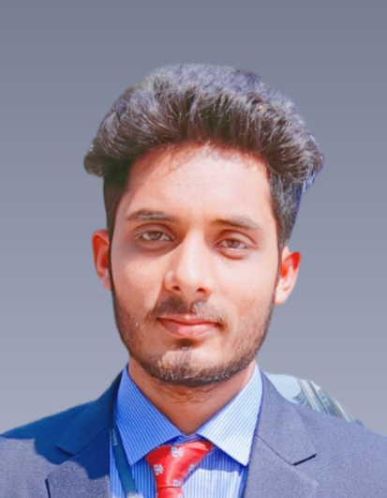

pranshumishra.akb@gmail.com

+91-9569287754 India

Pranshu Mishra

# Career Objective- Sample

To work in an organization where I can utilize my technical competencies in the area of Data Processing & hosting/Software Development and grow along with organization goal.

# Technical Skills

Programming Language: C , C++, Core Java, HTML, CSS, JavaScript, Node Js, MongoDB,

Express JS, MySQL , DSA.

# Interpersonal Skills (Top 3)- Sample

* Leadership Skills
* Communication Skills
* Problem Solving

# Personal Details

# Date of Birth: 11-10-2003.

# Father’s Name: Mr. Jantri Prasad mishra.

# Address: Meethepur Ambedkar nagar U.P.

# Language Known:Hindi, English.

# Education-Sample

I am pursuing MCA from ABES Engineering collage Ghaziabad U.P. 2023-25.

**Bachelor's of Computer Application** From

CSJM University Campus Kanpur U.P. in 2020-2023

**Senior Secondary (12th)**

A.V.M. Inter collage ambedkar nagar U.P. in 2020

**Secondary (10th)**

A.V.M. Inter collage ambedkar nagar U.P. in 2018

# Projects

**Project 1:**

Title: Real Time Chat application.

Technology: HTML, CSS,JavaScript,Node JS,MongoDB

Description: In which persons can chat

At a time. If any new person joins the chat then all members get notified.

Link: https://github.com/pranshu7272/real

**Project 2:**

Title: Travel Egency.

Technology: HTML,CSS,JavaScript,GSAP, PHP,MySQL.

Description: Developed a web app for travel planning and booking with features like secure booking, real-time updates, user profiles, secure payments and mobile compatibility.

Link: https://github.com/pranshu7272/Tech-Titans1

# Training & Certifications

* HackerRank Basic SQL Certificate
* Great Learning DSA with C.

# Co/Extra Curricular Activities-Sample

* Participated in Web-a-thon in IMS Engineering collage.
* Participated Hack-A-Thon in ABES Engineering collage.

# Achievements- Sample

* 4 star coder on HackerRank
* 50 Questions solve in leetCode

# Hobbies- Sample

* Reading Books
* Listening Music
* Coding